* In the United States, what is typically the number of channels?
* What bandwidth is required by these channels?
* What problem exists with this channel plan? Are all channels equally usable? How is this channel plan similar or different to how FM radio stations are allocated in the US?
* What are the most commonly used channels for 2.5GHz wifi? Why are they the most common?
* Using a tool such as NetSurveyor (<http://nutsaboutnets.com/netsurveyor-wifi-scanner/)> , scan the wireless space in your area. Allow the scan to run for at least 5 to 10 minutes. Take a screenshot of the Channel Heatmap and Spectrogram.
* What channels are the most crowded? If you’re having trouble finding a crowded area, conduct your scan at DSU or near a school/apartment building. Which would be the best channels to use to avoid interference with other channels?

1. 3 non-overlapping channels, 23 overlapping channels
2. 22 MHz
3. Channels 1, 6, &11 (they make the most use of they don’t overlap over the spectrum… but when everybody is using it the bleed is probably worse)
4. 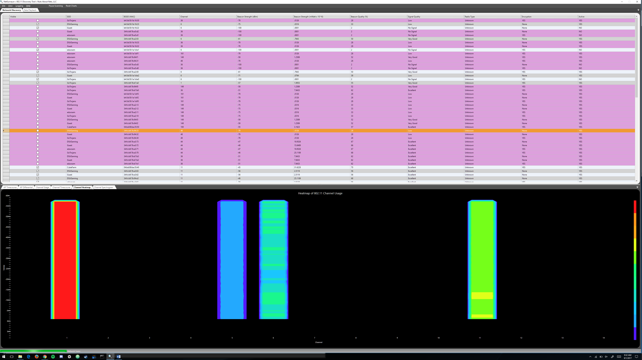
5. Channel 1 is terrible, channel 5,6, and 11 are being used although not so bad. To avoid bleed, probably use channels 3, 8, 9, & 14